Domain information

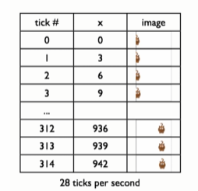

Function definition

* Given current x-coordinate, produce the next one (+ speed)
  + Where speed is a constant, in this case, SPEED = 3

